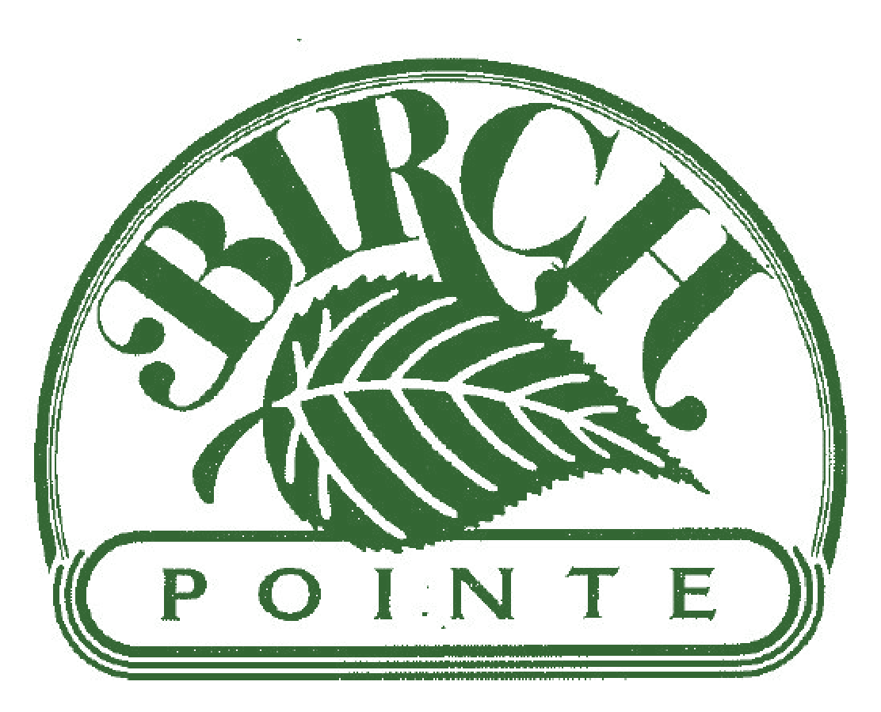
Birch Pointe CONDOMINIUM ASSOCIATION Newsletter

"A self-managed and run community composed of a volunteer board that works to keep costs low while striving to enhance property values and provide efficient leadership through open and honest communication."

Hello Birch Pointe Neighbors!

We would like to share an array of information with you to bring you up to date with future projects, finances, real estate status, general reminders and requests.
Spring has finally arrived and so begins our landscaping clean up. We hope you have noticed the great work the crew of Green Side Up has begun around the community! We would like to send out special thank you to those who go above and beyond by creating beautiful patio and deck gardens that enhance our surroundings and help to keep the common areas clean and attractive.
We are currently entertaining bids to have the exterior of all buildings washed to remove mold and dirt. Look for upcoming fliers and emails for dates and instructions regarding the project. ONE VERY IMPORTANT REQUIREMENT is that Everyone’s patio or deck will need to be Completely Emptied of All Items for the service. Please keep a close eye out for the upcoming dates, especially if you are planning to be away from home in the next 4-6 weeks. Thanks!!

Living in Harmony - Condominium Living
Living in a condominium community has many benefits. Which we have obviously decided for ourselves by choosing Birch Pointe as our home. By living in a community where we have immediate neighbors surrounding us from the top, bottom and side, it is important to remember those neighbors as we go about our daily activities. Please take time to think how your actions and those of your guests may impact others. For those who find themselves a bit disturbed by noise or noticing a neighbor not curbing a pet, we encourage you to take the time to introduce yourself and express in a friendly, respectful manner your concern and resolve the issue while hopefully making a friend in your neighbor. It’s possible the person(s) has no idea they are disturbing you.
Many of the complaints we receive are for chronic issues such as loud music, pet waste, abusive language, speeding within the community, and parking. These problems are easy to resolve if we all use a little common sense and a healthy dose of common courtesy.
The Birch Pointe Board retains the authority to address habitual offenses in an administrative manner but we cannot referee disputes or come to the scene of a conflict. If there is a chronic problem you wish to make the Board aware of, please feel free to write us. The issue will be discussed, determining if it is truly a violation of by-laws and/or Code of Conduct. If necessary, we will contact our NCCPD Community Officer for his expertise in County Ordinance(s) and draft a letter to address the problem, possibly assessing fines to the home owner.

If you have a problem with someone who you do not feel safe approaching, please call 911.
Thank you to everyone who makes Birch Pointe a pleasant, peaceful, and friendly place to call home!

Why Are Census Forms Important???? One example:
On a Sunday morning a pine tree was uprooted during a wind storm and found leaning against a building. In order to secure the tree, cut and remove it, a number of cars needed to be moved from the area. Board members went door to door (and neighbors came out) in an attempt to identify the cars and contact the owners. Even with the swift team response effort, one car was left unclaimed. The current census forms were referenced but, regrettably, neither the license plate or the make of car could be matched. The example does have a good ending, however; Thankfully the owner arrived while the work was being completed. We can only imagine the shock when they came out and saw everything going on and a boom truck right beside their car!
If you haven’t done so already, please take a few minutes to complete a census form yourself and, if applicable, forward one to your renters. Completed forms can be dropped off at the maintenance shed at any time. (see attached form at the end of newsletter)

Building Captains
We would like to reinstate the “Building Captains” program. We are looking for volunteers from each building (or pod) who would meet periodically and communicate with a Board liaison. We are also considering a “Block Call” program in coordination with New Castle County Police. Please contact Susan Yeatman at syeatman@birchpoint.net to express your interest in volunteering or with any questions.

IMPORTANT!!!!

“Unit Owners’ delinquent with their Association Fees constitute a hardship to the community as a whole, and impede and impair the ability of the Council to manage the affairs of the Association.”

If your account is delinquent Immediate Action is REQUIRED.
Please contact Treasurer Monica Rieder if you are in arrears. She will present your case to the Council to see if a payment plan can be approved.

  - Monthly Condominium Association fees not paid in full as of the 15 days post your due date, your account will be assessed a late fee in the amount $25. (for each month delinquent)
  - Dishonored checks or ACH payments may require payment by certified check or cashier’s check or money order for up to 6 (six) months following the first dishonored check or ACH. And up to 12 (twelve) months following receipt of any subsequent dishonored check or ACH payment.
  - Any Unit Owner who is more than 45 days delinquent in the Monthly Association fees will receive a written notice advising the Unit Owner that if the account is not paid in full within 15 days, the Association may take any of the following actions:
    - report the delinquency to the appropriate credit bureaus
    - suspend any centrally supplied utility or service and turn the matter over to the Association’s attorney for collection, including, but not limited to a foreclosure action, without further notice.

Consider signing up for Birch Pointe’s ACH program! It is an automatic and convenient way to pay monthly dues.
A one-time $15 credit will be applied when enrolling.
Contact Monica for more info at mrieder@birchpointe.net – or see our website to download the necessary form.

Dumpsters are for household trash and recycling.
Do Not put mattresses, furniture or carpets, etc besides or in the dumpster. If you have large items to be removed, you will need to have a pick up arranged by a private source. Our waste removal company is not contracted to pick up large items or overflow.
When any offender is identified, the special pick up fee will be invoiced to their account with an additional fine. Owners who have rental units, this cost will be forwarded to your account so please communicate this information to them directly.
Everyone’s cooperation and assistance is appreciated.

Community Reminders:

Safety: Front security doors are to be kept shut.
They may be propped open ONLY for a short time while moving heavy objects in and out of the building. This is for everyone’s safety!

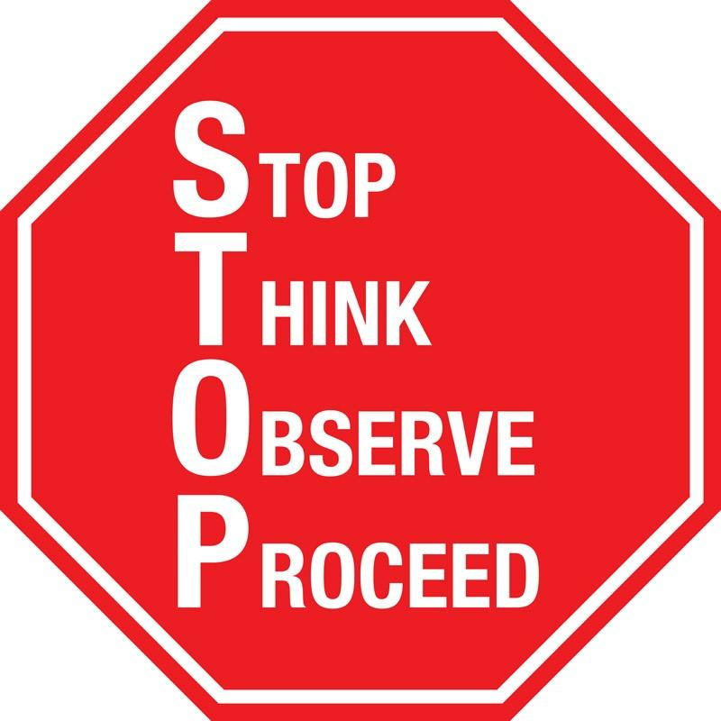
Traffic
SLOW YOUR ROLL!!! And STOP at the stop signs! They are put there for a reason. Cars backing out, owners walking pets, children walking from their bus stop and people picking up mail all may be difficult to see, especially at night. Be responsible and considerate.

Parking
Please have consideration for your neighbor by asking your guests to park in the overflow areas leaving spaces in front of the building for owners/tenants. Unregistered or abandoned motor vehicles present for more than seven consecutive days may be removed at the unit owner’s expense.

Handicapped Parking
Observe the handicapped parking spots located throughout the community! They are to be used only by vehicles with the appropriate state handicapped license plates or hang-tags. Birch Pointe reserves the right to remove vehicles not in compliance at the vehicle owner’s expense.
Pet Policies
Pick up after your pet! Failure to clean up waste will result in a $50 fine. Pets must also be leashed at all times when being walked.

Smoking Policies
Smoking is prohibited in all building common areas including hallways and staircases; light up only once outside.

Birch Pointe Directory/Important Numbers:

 General Property Management Questions

Eric Kennedy – phone: (302) 685-4310; e-mail: ekennedy@birchpointe.net

 Maintenance Issues and Questions

Maintenance staff (Dennis, Eric) – e-mail: maintenance@birchpointe.net

 Account Statements / Condo Fee Questions / ACH Payment Sign-Up

Monica Rieder – e-mail: mrieder@birchpointe.net

 Birch Pointe Maintenance Emergencies

phone: 1-267-474-2907; e-mail: maintenance@birchpointe.net

Board meeting of April 18, 2016

Board Attendees:

Tami Cooper – President.……………tcooper@birchpointe.net Monica Rieder – Treasurer...........mrieder@birchpointe.net
Susan Yeatman – Secretary.........syeatman@birchpoint.net Cheryl McDonaugh– MAL.…cmcdonaugh@birchpointe.net

Meeting Details:
Real Estate Status: Resources such as Realtor.com, Trulia.com, Zillow.com, and Estately.com

(12) Units on market: 4 On Birch Circle: all regular 1 with price cut
2 On Claremont Court: all regular 1 with sale pending/under contract
4 On Diana Drive: 3 regular, 1 short
4 On Haley Court: all regular 1 with sale pending; 2 with price cuts

(2) Unit(s) in foreclosure/up for sheriff’s sale: 1 Foreclosure on Birch Circle Sold 3-10-2016
1 Sheriff’s sale on Birch Circle Bank Buy-back on 3-8-2016

(3) Unit(s) sold: 1 on Diana Drive 3-25-2016
1 on Claremont no date given

Notes:

- Let a member of the Board know if you are aware of a new listing in Birch Pointe, or if YOU are moving and planning to sell your own condo.
- Eric is the Birch Pointe real estate liaison and can provide many of the essential documents, forms, and certifications needed for property transfer for a $25 fee.
- Birch Pointe has been recertified by HUD allowing them to obtain FHA insured mortgages.
- Birch Pointe has a policy regarding investors to protect the interests of ALL owners which must be disclosed to potential buyers, either directly by the seller or by his/her realtor. The document outlining this policy – established in 2013 – is clearly outlined on our website.
Collections Report:

(1) Total collected in HOA fees for the month: February $94,970 including a $2,000 payment for the
purchase of a unit designated as an
investment property

(2) Large(r) payments received for the month: $3,960 for owner paying entire year’s HOA fees

(3) March HOA fees remitted to date: $61,755

Treasurer’s Report:

(1) Total operating costs for the month: March $94,970.00

(2) Major expenses: $8,500 for spring landscaping/clean-up/mulching by Green Side Up
$5,170 for final payment for Claremont Court leak
$4,383 for annual spring pest treatment
$3,500 for salting and snow shoveling
(3) Capital improvement expenditures: $12,735 for balcony repair on Haley Court
$900 for intercom upgrade on Diana Drive

(4) Status of Birch Pointe accounts: Operational Reserve = $15,301
(see financial summary at end) Reserve = $254,328

Board Discussions:

- Financial reports and updates
- Real Estate report review
- Landscaping contract and future planning
- Exterior building cleaning - Bid review
- Dog Park - waste and containers
- New Castle County Community Officer - complaints, neighborhood Call Block Watch, hiring an Officer for problem areas and traffic issues
- Specific noise complaints
- Building Captains
- Newsletter
- Rescheduling May date for monthly meeting

April 2016 Financials

– Operating Account

Beginning Balance: $ 50,995.63

Inflow – Operating Income: $ 94,970.00
Inflow – One-time Transfers (from ORA*): $ 0.00
Outflow – Operating Expenditure: $ 88,617.25

Outflow – Capital Expenditure: $ 13,635.00
Outflow – to Operational Reserve*: $ 0.00

Ending Balance: $ 43,713.38
Target Ending Balance: $ 50,000.00
Surplus / Deficit: $ -6,286.62

– Operational Reserve Account

Beginning Balance: $ 15,300.70

Inflow – Periodic Transfers: $ 0.00
Inflow – Interest: $ 0.65
Outflow – Periodic Transfers*: $ 0.00

Ending Balance: $ 15,301.35

* monies are transferred into/out of Operational Reserve Account (ORA)
as needed to cover expenditures, maximizing earned interest

– Reserve Account

Beginning Balance: $ 254,306.31

Inflow – Periodic Transfers: $ 0.00
Inflow – Interest: $ 21.60
Outflow – Periodic Transfers: $ 0.00
Outflow – One-time Transfers: $ 0.00

Ending Balance: $ 254,327.91

Target Ending Balance: $ 250,000.00

Surplus / Deficit: $ 4,327.91
