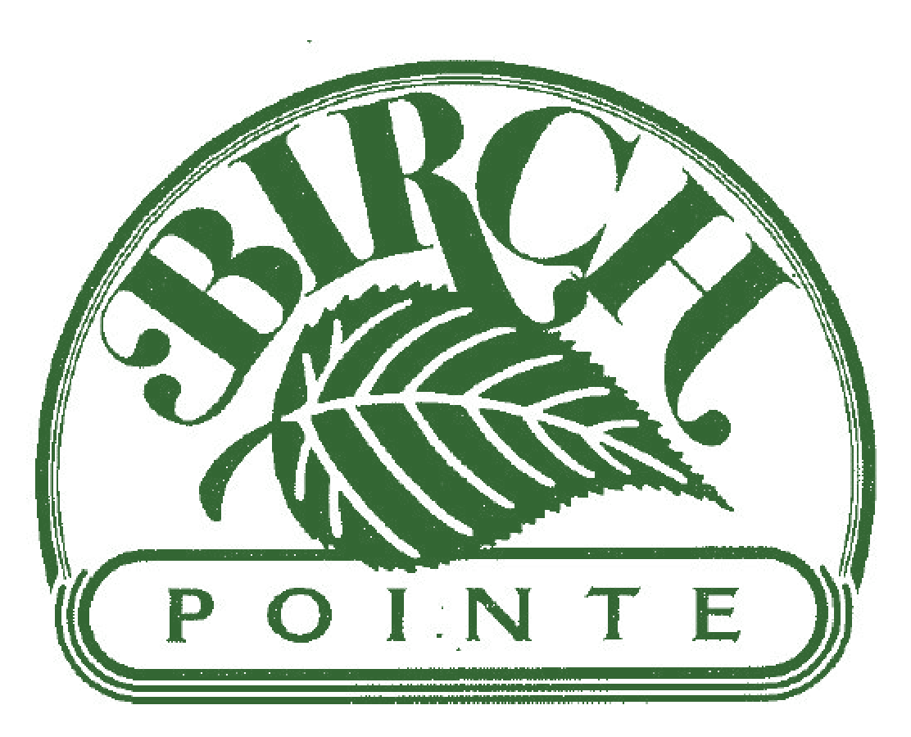 **Birch Pointe *CONDOMINIUM ASSOCIATION* Newsletter**

**"A self-managed and run community composed of a volunteer board that works to keep costs low while striving to enhance property values and provide efficient leadership through open and honest communication."**



**WE asked and YOU answered! Strengthening our Community –**

**The Building Captains’ Committee has been established!**

We are off to a Great Start!

Allow us to introduce our current Building Captains!

Sandra Link – 3600/3700 Birch Circle Eileen Hackett - 4100 Birch Circle

Randy Deamond – 4200 Birch Circle Susan Yeatman - 4300 Birch Circle

Debby Barber - 4400 Birch Circle

Bill & Wendy Pugh - 5100 Claremont Court Trish Minogue - 4800 Claremont Court

John Byrd - 5000 Diana Drive Evelyn Hayes – 5100 Diana Drive

Liz Haines - 5200 Diana Drive Mike Martin - 5300 Diana Drive

Monica Rieder - 5500 Diana Drive

The initial Building Captains’ meeting was a “Meet & Greet” on June 14th.  We were able to introduce our-selves, share our vision and collectively build the foundation of the program. One of the first plans is joining forces with the New Castle County Police Department and their Block Watch Program:

*…The Block Watch Program is presented to any civic association or residential group by the NCCPD and follows the same format as the community watch program. Instead of mobile patrols, a telephone network will be set up to create a flow of information between the community and the police*…

The next Building Captains’ meeting is scheduled for Monday, June 27. Still, our search continues: we are looking for more volunteers, especially for members in the remaining buildings and would welcome represent-tation from **Haley Court**. Building Captains’ add great value to our community and we sincerely hope that you consider joining. If interested, please send your inquiries for joining to [TCooper@BirchPointe.net](mailto:TCooper@BirchPointe.net) or [SYeatman@BirchPointe.net](mailto:SYeatman@BirchPointe.net)

All owners are welcome but please note all members must be in good standing with their HOA accounts.

**The Board is also still looking to add new members!**

This role is vital to our self-managed Status. Remember Birch Pointe’s mission statement:

**"A self-managed and run community composed of a volunteer board that works to keep costs low while striving to enhance property values and provide efficient leadership through open and honest communication."**

Please consider sending your interest to [TCooper@BirchPointe.net](mailto:TCooper@BirchPointe.net) or any member of the Board.

**IMPORTANT SAFETY CONCERN!!!**

There have been two reported vehicle break in’s and one attempted home robbery in the past few weeks. PLEASE be mindful of your surroundings!

Lock Your Car. Do NOT leave the front building door open unattended. Lock your personal doors.

And CALL 911 for ANY SUSPICIOUS ACTIVITIES!!

A GREAT, BIG **THANK YOU** to each and every one of our residents!!!

Vesta Wash successfully cleaned the entire community in 11 business days.

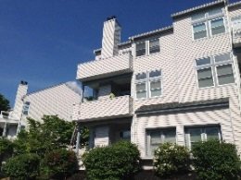

We had a few hickups along the way, and collectively we (BP and Vesta Wash)

learned a few lessons. Your cooperation and patience was greatly appreciated!! And we know

it took both because, just like you, the board also had patio furniture in the living room, plants

that were confused and late flowers being planted! But the outcome is that we now look like a

“jewel shining in the sun!”

Now with all this beauty and cleanliness we must address the dumpster area again.

***Dumpsters are for household trash and recycling…ONLY***

**Do Not** put mattresses, furniture, carpets, appliances, etc. in or besides the dumpsters. If the dumpster closest to you is full, please be courteous and take it to the next closest bin. **Do Not Leave Trash on the Outside of the Dumpsters.** If you have large items to be removed, you will need to have a pick up by a private source as our waste removal company is NOT contracted to pick up large items or overflow.

If you DO see a resident breaking the by-laws, please e-mail maintenance@birchpointe.net. We will keep your identity confidential. Once the offender is identified, the resulting special pick up fee will be charged to their account, along with an additional fine. For owners who have rental units, this cost will be invoiced to YOUR account so please communicate this regulation directly to them. Everyone’s cooperation and assistance is appreciated. This type of extra service for pick-ups can impact our budget; please let’s all work together!

**IMPORTANT!!!! PLEASE DO NOT IGNORE**

**Statements will be €mailed to all accounts that have a past due balance. It is imperative that you review the document, and contact treasurer Monica Rieder to coordinate a payment plan.** She will present your case to the Council to ascertain if a payment plan can be approved. We have been successful in making agreements with a few residents over the past two months and moving forward without legal assistance. This is truly our goal - to work together. Please note that if a delinquency continues, Birch Pointe ***will be reaching out for legal assistance regarding accounts that are not addressed and/or actively making substantial, consistent payments***.

**“Unit Owners’ delinquent with their HOA Fees constitute a hardship to the community as a whole, and impede and impair the ability of the Council to manage the affairs of the Association.”**

1. *Monthly Condominium Association fees not paid in full as of 15 days past the due date may be assessed a late fee in*

*the amount $25. (for each month delinquent)*

1. *Dishonored checks or ACH payments may require payment by certified check, cashier’s check or money order for up*

*to 6 (six) months following the* ***first*** *dishonored check or ACH, and up to 12 (twelve) months following receipt of any subsequent dishonored check or ACH payment.*

1. *Any Unit Owner who is more than 45 days’ delinquent in the Monthly Association fees will receive a written notice*

*advising the Unit Owner that if the account is not paid in full within 15 days, the Association may take any of the following actions:*

* 1. *report the delinquency to the appropriate credit bureaus*
  2. *suspend any centrally supplied utility or service and turn the matter over to the Association’s attorney*

*for collection, including, but not limited to a foreclosure action, without further notice.*

Consider signing up for Birch Pointe’s ACH program! It is an automatic, convenient way to pay monthly dues.

***A one-time $15 credit will be applied when enrolling***.

Contact Monica for more info at [MRieder@birchpointe.net](mailto:MRieder@birchpointe.net) – or see our website for the necessary form.

***Community Reminders and Reference Information***

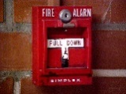**FIRE ALARM SYSTEMS**

The Fire Alarm systems in the buildings (with the exception of 3300 and 3400 Haley Court) do NOT automatically contact 911. They are an ALARM to check your immediate area and VACATE

the building until cleared by Fire Department. Do not assume it is a FALSE ALARM!

**Safety: Front security doors are to be kept shut**

They *may* be propped open ONLY for a short time while moving heavy objects in and out of the

building. This is for everyone’s safety!

**Building Lights**

If a light out in your building, please contact [maintenance@birchpointe.net](mailto:maintenance@birchpointe.net) or the Building Captain. Once notified the maintenance team will replace ASAP.

 **Traffic**

**SLOW YOUR ROLL!!!** And STOP at the stop signs! They are put there for a reason. Cars backing out, owners walking pets, children walking from their bus stop and people picking up mail all may be difficult to see, especially at night. Be responsible and considerate.

**Parking**

Note that residents are NOT permitted to park their commercial vehicles in the community.

Please have consideration for your neighbor by asking guests to park in the overflow areas,

leaving spaces in front of the building for owners/tenants. Unregistered or abandoned motor vehicles present for more than seven consecutive days may be removed at the unit owner’s expense.

**Handicapped Parking**

Observe the handicapped parking spots located throughout the community! They are to be used **only** by vehicles with the appropriate state handicapped license plates or hang-tags. **Birch Pointe reserves the right to remove vehicles not in compliance at the vehicle owner’s expense.**



**Smoking Policies**

**Smoking is prohibited in all building common areas** including hallways and staircases; light up only once outside and do not toss butts onto property please dispose of safely and properly.

 **Replacement Windows: *Sharing information – This is not an endorsement.***

A resident has found a vendor – [KBower@northamericanwindow.com](mailto:KBower@northamericanwindow.com) – which carries replace-ments of the vacuum sealed glass units in the original Kolby & Kolby window assembly. The company is located in West Chester, PA with Kirk Bower being the contact person there. The serial number on each window assembly located between the glass panes is needed in order to price and reorder the units.

**Birch Pointe Directory/Important Numbers**

**⮚ General Property Management Questions**

Eric Kennedy – phone: (302) 685-4310; e-mail: [ekennedy@birchpointe.net](mailto:ekennedy@birchpointe.net)

**⮚ Maintenance Issues and Questions**

Maintenance staff (Dennis, Eric) – e-mail: [maintenance@birchpointe.net](mailto:maintenance@birchpointe.net)

**⮚ Account Statements / Condo Fee Questions / ACH Payment Sign-Up**

Monica Rieder – e-mail: mrieder@[birchpointe.net](mailto:birchp.treasurer@gmail.com)

**⮚ Birch Pointe Maintenance Emergencies**

phone: 1-267-474-2907; e-mail: [maintenance@birchpointe.net](mailto:maintenance@birchpointe.net)

**⮚ Condominium Association Board Members**

Tami Cooper, President [TCooper@BirchPointe.net](mailto:TCooper@BirchPointe.net)

Monica Rieder, Treasurer [MRieder@BirchPointe.net](mailto:MRieder@BirchPointe.net)

Susan Yeatman, Secretary [SYeatman@BirchPointe.net](mailto:SYeatman@BirchPointe.net)

Manuel Harnisch, MAL/Treas. Advisor [treasurerbp@gmail.com](mailto:treasurerbp@gmail.com)

Jim, Coll, MAL [JColl@BirchPointe.net](mailto:JColl@BirchPointe.net)

Cheryl McDonaugh, MAL [CMcdonaugh@birchpointe.net](mailto:CMcdonaugh@birchpointe.net)

_____________________________________________

***Board Meeting of June 13, 2016***

**Board Attendees:**

Tami Cooper – President.…………………[tcooper@birchpointe.net](mailto:tcooper@birchpointe.net)

Monica Rieder – [Treasurer................mrieder@birchpointe.net](mailto:Treasurer............mrieder@birchpointe.net)

Susan Yeatman – Secretary………….syeatman@birchpointe.net

Manuel Harnisch – MAL/Advisor….…….treasurerbp@gmail.com

Jim Coll – MAL………………………………….…jcoll@birchpointe.net

**Board Discussions:**

* Financial report and updates
* Delinquent accounts – updates and future action(s)
* Real Estate report and review
* Exterior building cleaning – satisfaction and payment
* Building structural maintenance (decks, intercoms, etc.)
* Maintenance team
* Safety – fire alarm, speeding concerns/actions, stop signs concern/actions
* Building Captains Committee – members, recruitment
* Recruitment of new Board members
* Resident complaints and resolutions
* No Board meeting in the month of July

**Meeting Details:**



**Real Estate Status:** Resources such as Realtor.com, Trulia.com, Zillow.com, and Estately.com

(12) Units on market: 4 On Birch Circle: regular 2 with sales pending

2 On Claremont Court: regular 1 with sale pending; 1 with price drop

4 On Haley Court: regular 1 with sale pending

(2) Unit(s) sold: 2 on Birch Circle 5-31-2016 and 6-13-2016

2 on Haley Court 5-27-2016 and 6-7-2016

1 on Claremont 5-16-2016

1 on Diana Drive 6-9-2016 (short sale)

**Notes**:

* Let a member of the Board know if you are aware of a new listing in Birch Pointe, or if YOU are moving and planning to sell your *own* condo.
* Eric is the Birch Pointe real estate liaison and can provide many of the essential documents, forms, and certifications needed for property transfer for a $25 fee.
* Birch Pointe has been recertified by HUD allowing them to obtain FHA insured mortgages.
* Birch Pointe has a policy regarding investors to protect the interests of ALL owners which must be disclosed to potential buyers, either directly by the seller or by his/her realtor. The document outlining this policy – established in 2013 – is clearly outlined on our website.

**MC900383244[1]**

**Collections Report:**

(1) Total collected in HOA fees for the month: May $95,330

$125 re-certification fees for resales

(2) Large(r) payments received for the month: $2,640 for back HOA dues from sale of bank owned property

1 at $1,500; 1 at $990; 3 at $660; 6 between $400 and $675

(3) March HOA fees remitted to date: $68,320

**Notes**:

* Owners in financial difficulty should speak with a Board member to discuss their situation and arrange a payment plan/schedule to address ways of clearing up past balances.
* Consider signing up for Birch Pointe’s ACH program! It is an automatic and convenient way to pay monthly dues. A one-time $15 credit will be applied when enrolling. Contact Monica for more info at [mrieder@birchpointe.net](mailto:mrieder@birchpointe.net) – or see our website to download the necessary form.

**Cable service will be disconnected after a 90 day delinquency unless a**

**Board-approved payment plan is in place.**

**MC900445212[1]Treasurer’s Report:**

(1) Total operating costs for the May: $83,331 (quite modest)

(2) Major expenses: $18,520 for 3 sewer grate rebuilds; 2 railing replacements; retaining wall

(other than normal utilities) $5,500 for monthly landscaping plus additional mulching

$980 for tax preparation and financial audit/statement

(3) Capital improvement expenditures: none for the month

(4) Status of Birch Pointe accounts: Operational Reserve = $15,302

(see financial summary at end) Reserve = $254,370

**May 2016 Financials**

– **Operating Account**

**Beginning Balance:** $ 60,515.09

**Inflow – Operating Income:** $ 95,454.00

**Inflow – One-time Transfers** (from ORA*)**:** $0.00

**Outflow – Operating Expenditure:**  $ 83,330.92

**Outflow – Capital Expenditure:** $ 0.00

**Outflow – to Operational Reserve*:** $ 0.00

**Ending Balance:** $ 72,638.17

**Target Ending Balance:** $50,000.00

**Surplus / Deficit:** **$ 22,638.17**

– **Operational Reserve Account**

**Beginning Balance:** $ 15,301.98

**Inflow – Periodic Transfers:** $ 0.00

**Inflow – Interest:** $ 0.65

**Outflow – Periodic Transfers*:** $ 0.00

**Ending Balance:** **$ 15,302.63**

* monies are transferred into/out of Operational Reserve Account (ORA)

as needed to cover expenditures, maximizing earned interest

– **Reserve Account**

**Beginning Balance:** $ 254,348.81

**Inflow – Periodic Transfers:** $ 0.00

**Inflow – Interest:** $ 21.60

**Outflow – Periodic Transfers:** $ 0.00

**Outflow – One-time Transfers:** $ 0.00

**Ending Balance:** $ 254,370.41

**Target Ending Balance:**  $ 250,000.00

**Surplus / Deficit:** **$** **4,370.41**

**BIRCH POINTE CONDOMINIUM ASSOCIATION CENSUS FORM**

**P.O. Box 1195 Hockessin, DE 19707**

Unit Address: __________________________ Number of Persons Residing in Unit: _______

Legal Owner’s Name: __________________________________________________________

E-Mail Address: _______________________________________________________________

Legal Owner’s Mortgage Company: ________________________________________________

Legal Owner’s Insurance Company: ________________________________________________

Legal Owner’s Phone Number(s): _______________________ _________________________

Home Work / Mobile

If Non-Resident, Mailing Address: _________________________________________________

_________________________________________________

Tenant(s) Full Name(s) and Phone Numbers:

________________________________________ _____________________ ____________________ Name Home Number Work / Mobile

________________________________________ _____________________ ____________________ Name Home Number Work / Mobile

Emergency Contact Info: ______________________________________ _______________________

Name Phone

Vehicle(s) Owned by Occupant(s):

_____________ ____________________________________________ ____________________ Year Make / Model / Color License Plate Number

_____________ ____________________________________________ ____________________ Year Make / Model / Color License Plate Number

Pet(s) in Unit: ________________________________________________________________________

Size / Breed

Are you currently in possession of the Rules and Regulations of the Birch Pointe Condominiums? Yes / No

I understand that the above information is for the sole use of Birch Pointe Condominiums Association and its authorized agents in maintaining the community and providing emergency services. I also acknowledge that I must notify Birch Pointe Management if there are any changes in this information and/or if my unit is rented or sold.

____________________________________________________________ ______________________

Signature of Owner Date

**Census: 4-21-2016**